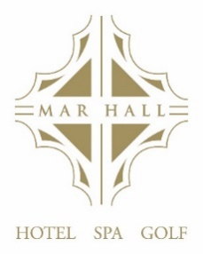
` `

MOTHER’S DAY SUNDAY LUNCH

oOo

Parisienne of Melon with Creamed Goats Cheese, Spiced Rum and Prune Syrup

Ballotine of Chicken with Apricot Sage, Pistachio Aioli and Crisp Leaves

Pan Fried West Coast Scallops with Pea and Mint Puree, Black Pudding Crumb and Lemon Foam

Ham Hock Terrine with Tomato Chutney and Arran Oatcakes

OOo

Smoked Paprika and Lentil Soup

OOo

Roast Sirloin of Scotch Beef with Dauphinoise Potatoes, Yorkshire Pudding and Sauce Chasseur

Grilled Sea Bass Fillet with Seared Baby Gem Parmentier Potatoes and Saffron Mussel Broth

Pan Roasted Chicken Supreme, Pommes Forestiere, Buttered Greens and White Truffle and Tarragon Veloute

Gnocchi with Mediterranean Vegetables in a Creamy Garlic Sauce and Rocket Salad

oOo
Tonka Bean Crème Brulee served with Shortbread
Belgium Chocolate Torte with Crème Anglaise
Lemon Pannacotta Torte with a Raspberry Coulis
Hand-Selected Cheeses with Oatcakes and Tomato Chutney

