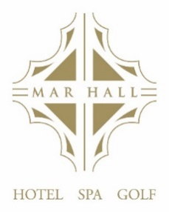
`

CRISTAL A LA CARTE

oOo

Spiced Tomato and Chickpea Soup (V)
£8.50
Pan Seared West Coast Scallops, Pea and Mint Puree, with a Samphire and Smoked Paprika Oil
£12.95
Chicken Liver Pate, Arran Oatcakes, Red Onion Marmalade and a Micro Salad
£8.95
Crescent of Melon, Lemon Sorbet and Fruit Compote (V)
£7.95
Roast Portobello Mushroom with Goats Cheese, Pepperonatta and Aged Balsamic (V)
£8.95

oOo

Pan Roast Fillet of Scotch Beef, Roast Tomato and Portobello Mushroom, Peppercorn Café Au Lait and Chunky Chips
£35.00
Pan Roast Chicken Supreme, Dauphinoise Potatoes, Buttered Greens with an Asparagus & Sage Veloute
£24.50
Confit of Duck Leg, Fondant Potatoes, Buttered Greens with a Stem Ginger & Orange Jus
£21.00
Grilled Salmon Fillet, Pomme Lynonaise & Broccoli with a Provencal Sauce
£25.50
Roasted Aubergine, Curried Ragu and Fried Halloumi (V)
£18.95

Sides - £5.00

Chunky Chips
Onion Rings
Steamed Kale and Tender stem Broccoli

DESSERTS

Vanilla Crème Brulee with a Milk Chocolate Chip Cookie
£7.95
Cosmoplitian
£10.50

Chocolate Torte with Vanilla Ice Cream
£7.95
Espresso Martini
£10.50

Sticky Toffee Pudding with Vanilla Ice Cream
£7.95
Cointreau
£4.50

Lemon Panna Cotta Torte with Passion Fruit Sorbet
£7.95
Lemoncello
£4.50

Hand-Selected Cheeses with Oatcakes and Tomato Chutney
£12.95
Kopke LBV Port 2016
£5.50

OOo

SPECIALIITY COFFEES

Amaretto Coffee - £8.50
Baileys Coffee - £8.50
Gaelic Coffee - £8.50
Hot Toddy - £8.50
Irish coffee - £8.50
Baileys Hot Chocolate - £8.50

